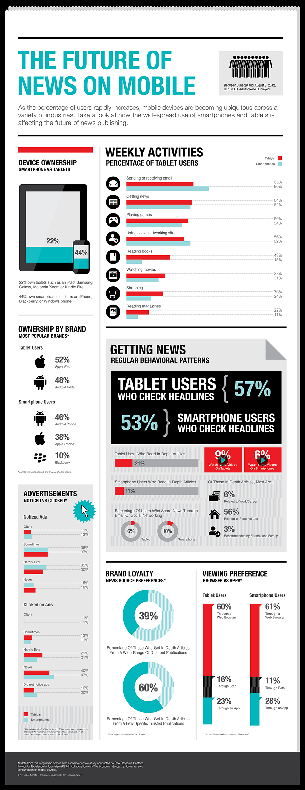

<http://www.journalism.org/2012/12/05/featured-infographics-selected-pej-economist-challenge/>

Gestalt's Rules of Visual Perceptions

1. **Proximity**: All the information is inter-related and yet some facts are nicely separated with the white space background. In the chart “viewing preference”, bar charts of tablet and smartphone users are separated with white space, without any other distinction.
2. **Similarity**: In almost all the charts, blue and red colors are used for tablets and smartphones respectively, to indicate the different categories.
3. **Enclosure**: In the pie chart of “Brand Loyalty”, darker shade of blue is used to highlight the percentages over the whole pie. This highlight gives straight view of percentage being greater or less than 50.
4. **Closure**: Super thin dotted boundary lines are used to indicate the percentages of horizontal bar graphs. Even when these lines are dotted, viewer’s eye can easily fill out the gap. In the middle and right section of the chart, background shading is avoided as it doesn’t add any further value to it.
5. **Continuity**: In all the horizontal graphs, y-axes are absent and yet our eyes see those bars lined up at the same point because of the consistent white space between the labels on the left and data on the right.
6. **Connection**: There isn’t any direct application of connection principle that can be seen. But it’s equally appealing to see the strong bonds between the charts. From top left to bottom right, it goes one step deeper into the analysis of tablets and smartphones.